FUTURE LAND PRICE PREDICTION

BY Data Science Team
VANISHA BOLLA
SWAPNA THATIPARTHI
ANANDINI KURAPATI
SAIKUMAR GUJJALVAR
SHIVASAI PALOJU
ARUN KUMAR KUMMARI
VAMSHI KUMMARI

SI No | CONTENTS |  |  |  | Page. No
 | ABSTRACT |  |  |  | 1
1 | INTRODUCTION |  |  |  | 2
2 | PROBLEM STATEMENT |  |  |  | 3
3 | SOFTWARE REQUIREMENT SPECIFICATION |  |  |  | 4-5
 | 3.1 | PURPOSE
 | 3.2 | OBJECTIVES
 | 3.3 | REQUIREMENTS
 |  | 3.3.1 |  | SOFTWARE REQUIREMENTS
 |  | 3.3.2 |  | HARDWARE REQUIREMENTS
4 | DATASET & METHODOLOGY |  |  |  | 6-9
 | 4.1 | DATASET DESCRIPTION
 | 4.2 | DATA COLLECTION
 | 4.3 | MACHINE LEARNING MODEL ARCHITECTURE
 | 4.4 | MODEL TRAINING
 | 4.5 | EVALUATION METRICS
 | 4.6 | DEPLOYMENT METHODOLGY
5 | IMPLEMENTATION |  |  |  | 10
 | 5.1 | SYSTEM IMPLEMENTATION OVERVIEW
 | 5.2 | MODEL TRAINING IMPLEMENTATION
6 | RESULT ANALYSIS |  |  |  | 11
 | 6.1 | PERFORMANCE EVALUATION
 | 6.2 | ANALYSIS & INSIGHTS
7 | CONCLUSION & FUTURE SCOPE |  |  |  | 12
 | 7.1 |  | CONCLUSION
 | 7.2 |  | FUTURE SCOPE

List of Figures

Figure No | Name of the Figure | Page No
1 | Sample Dataset | 6
2 | Model Accuracy | 7
3 | Streamlit user input page | 9
4 | Prediction Results | 11

ABSTRACT
Land price prediction is a complex task influenced by factors such as location, infrastructure, and socio-economic conditions. Traditional valuation methods rely on manual assessment and subjective judgment, often leading to inconsistent results and increased investment risk. This project presents an automated land price prediction system using machine learning techniques.
The model predicts land price per square foot by leveraging features such as city tier, proximity to key facilities, population growth, and infrastructure indicators. Additional factors like zoning, locality, government development plans, and flood risk are incorporated to improve accuracy.
Through effective data preprocessing, feature engineering, and model optimization, the system captures complex relationships between variables and land value. The proposed solution enables data-driven decision-making, helps identify undervalued properties, reduces risk, and supports smarter real estate investment strategies.

- INTRODUCTION
Land valuation plays a crucial role in real estate investment and urban development. Accurate estimation of land prices is essential for investors, developers, and policymakers, as incorrect valuation can lead to financial losses, poor investment decisions, and inefficient resource allocation. Traditional methods of land price assessment often rely on manual analysis, limited data, and subjective judgment, making them inconsistent and unreliable specially in rapidly growing and complex real estate markets.
With the advancement of Machine Learning and data-driven analytics, land price prediction has become more accurate, scalable, and efficient. This project aims to build an Automated Land Price Prediction System that leverages regression-based machine learning models to estimate land price per square foot. The system utilizes a wide range of features, including location attributes, proximity to infrastructure, environmental factors, population growth, and development indicators.
The proposed solution improves prediction accuracy, reduces dependency on manual evaluation, and enables faster decision-making. It helps identify undervalued properties, minimizes investment risks, and supports smarter real estate strategies—making it highly effective for modern data-driven investment and planning.

- PROBLEM STATEMENT
In the real estate industry, accurate land price estimation is critical for making informed investment and development decisions. Even small miscalculations in land valuation can lead to financial losses, missed opportunities, or inefficient allocation of resources. Traditional land valuation methods—often based on manual analysis, limited historical data, and subjective judgment—are slow, inconsistent, and highly dependent on individual expertise. Furthermore, with rapid urbanization and dynamic changes in infrastructure, population growth, and government policies, these conventional approaches fail to capture the complex factors influencing land prices effectively.
There is a growing need for an intelligent, accurate, and scalable system that can analyse multiple influencing factors and provide reliable land price predictions with minimal human intervention.
This project addresses that need by developing a Machine Learning–based Automated Land Price Prediction System capable of estimating land price per square foot using diverse features such as location, infrastructure proximity, environmental conditions, and growth indicators. The system aims to improve prediction accuracy, reduce human bias, support data-driven decision-making, and enhance overall efficiency in real estate investment and planning.

- SOFTWARE REQUIREMENTS SPECIFICATIONS
3.1 Purpose
The purpose of this project is to develop an automated system to predict land price per square foot using machine learning, replacing manual valuation with a faster, more accurate, and data-driven approach.
3.2 The main objectives of this project are as follows:
- To develop an automated system for predicting land price per square foot using machine learning techniques.
- To analyse and utilize multiple factors such as location, infrastructure proximity, and environmental conditions for accurate prediction.
- To build and optimize regression models for reliable and efficient land price estimation.
- To reduce dependency on manual valuation methods and minimize human bias and errors.
To support data-driven decision-making for investors and stakeholders in real estate.
3.3 Requirements
    - Software Requirements
The following software tools and platforms are required for the development and execution:
      - Operating System: Windows 11
      - Programming Language: Python 3.11 or above
      - Development Environment: Jupyter notebook
      - Streamlit Coding - VSCode
- Libraries and Frameworks
- Numpy – for numerical computations
- Pandas – for data handling
- Machine Learning for Model Development

    - Hardware Requirements
The following hardware components are required for the development, training, and deployment:
- Processor: Intel Core i5 or higher
- Memory (RAM): Minimum 8GB
- Storage: Minimum: 256 GB SSD / HDD
- DATASET & METHODOLOGY
4.1 Data Description
This dataset contains information about various land areas across different cities and states, focusing on factors that influence land price per square foot. It includes geographical, infrastructural, and development-related attributes. The dataset is used to build a machine learning model that predicts future land prices based on current conditions and growth.
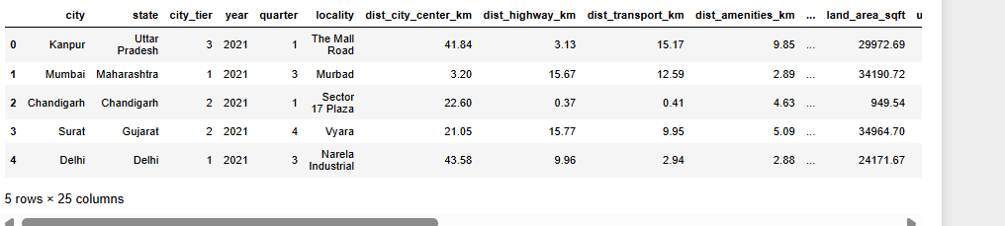
Fig 1: Sample Dataset
4.2 Data Collection
Data collection is a crucial step in building an accurate and reliable Land Price Prediction System. In this project, a structured dataset containing geographical, infrastructural, and socio-economic features is used to train and evaluate machine learning models.
Source of Data
- The dataset is collected from publicly available real estate data sources and synthetic data generation techniques.
- Data represents various cities, states, locality and zoning with different development levels.
- The dataset includes both high-value and low-value land samples for balanced learning.
Type of Data Collected
Location Data
- - city
- - state
- - locality
- - city tier
- Distance-based Features:
– Distance to city centre
– Distance to highway
– Distance to transport
– Distance to amenities
- Growth Indicators:
– Historical growth percentage
– Population growth percentage
- Infrastructure Features:
– Road quality score
– Utility access
- Planning & Risk Factors:
– Zoning type
– Government development plans
– Flood risk score
- Target Variable:
– Future Land price prediction
• Dataset Structure
- The dataset is organized in tabular format (CSV).
- The dataset is divided into:
– Training Set
– Testing Set
4.3 Machine Learning Model Architecture
Regression-based machine learning models such as Random Forest Regressor, XGBoost, Decision Tree and Linear Regression are implemented to predict land price. These models capture complex relationships between input features and land value.
4.4 Model Training
The models are trained using pre-processed and labelled data. Feature scaling, encoding, scaling is applied to improve model performance and accuracy.
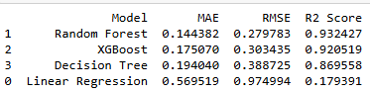

Fig 2: Model Accuracy
4.5 Evaluation Metrics
The model’s performance is evaluated using the following metrics:
- Mean Absolute Error (MAE)
- Mean Squared Error
- R² Score (Coefficient of Determination)
These metrics help assess prediction accuracy and model reliability.
4.6 Deployment Methodology
The deployment methodology explains how the trained Land Price Prediction System is implemented and made available for real-time use using a Streamlit-based application. The system integrates the trained Machine Learning model directly into an interactive interface for practical usage.
Model Export and Storage
After successful training and evaluation, the final trained model (such as Random Forest) is saved in a serialized format:
Land_price_pipeline.pkl using Pickle
.joblib (optional)
The trained model is stored locally and loaded into the Streamlit application during execution for real-time prediction.
Application Deployment using Streamlit
The entire system is developed using Streamlit, which combines both the user interface and processing logic in a single Python script.
No separate frontend (HTML, CSS, JavaScript) or backend (Flask/Django) is required.
The trained Machine Learning model is directly integrated into the Streamlit app.

System Functionality
The Streamlit application performs the following tasks:
Accepts user inputs such as:
- Location details (city, state, tier)
- Distance features (city centre, highway, transport, amenities)
- Growth and development factors
- Preprocesses the input data (if required)
- Loads the trained model
- Predicts the land price per square foot
- Displays the prediction instantly on the screen
User Interaction Flow
- The user enters land-related input features in the Streamlit interface
- The application processes the input data
- The trained model generates a prediction
- The predicted land price is displayed in real time)
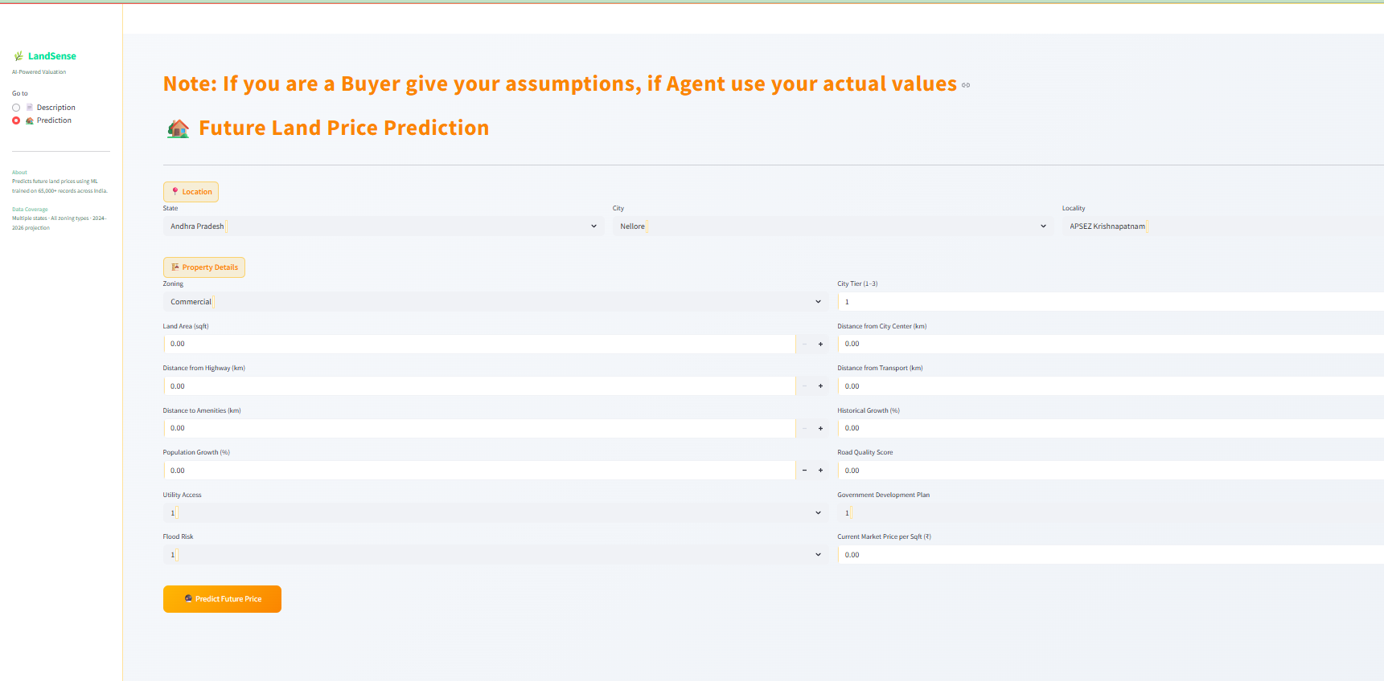
Fig 3: Streamlit User input page

- IMPLEMENTATION
5.1 System Implementation Overview
The Land Price Prediction System is an automated machine learning–based solution designed to estimate land price per square foot using multiple influencing factors. The system integrates advanced regression models to capture complex relationships between location, infrastructure, environmental conditions, and growth indicators.
5.2 Model Training Implementation
• Load and prepare the pre-processed dataset containing all relevant features and the target variable (predicted_land_price_sqft_2026)
• Perform data preprocessing steps such as handling missing values, encoding categorical variables.
• Apply feature engineering techniques to improve model performance and capture meaningful relationships.
• Train regression models such as Random Forest, XGBoost, Decision Tree or Linear Regression using the training dataset.
• Perform hyperparameter tuning to optimize model performance.
• Evaluate the model using test data and select the best-performing model.
• Save the final trained model in .pkl format for testing and deployment.

- RESULT ANALYSIS
6.1 Performance Evaluation
• The land price prediction model is evaluated using a separate test dataset.
• Performance is measured using evaluation metrics such as Mean Absolute Error (MAE), Root Mean Squared Error (RMSE), and R² Score.
• The model achieves good accuracy in predicting land price per square foot across different regions and feature combinations.
• The evaluation results demonstrate the model’s ability to generalize well on unseen data.
• The performance confirms the system’s suitability for real-time land price estimation and decision-making.
6.2 Analysis & Insights
The machine learning model successfully captures the relationship between various factors such as location, infrastructure, growth indicators, and land price. Feature engineering and preprocessing techniques significantly improved prediction accuracy and model performance. The model provides consistent and reliable estimates, reducing dependency on manual valuation methods.
Additionally, factors like proximity to city centre, infrastructure quality, and population growth were found to have a strong influence on land prices. The system helps in identifying undervalued land and supports smarter investment decisions while reducing risk and effort in real estate analysis.
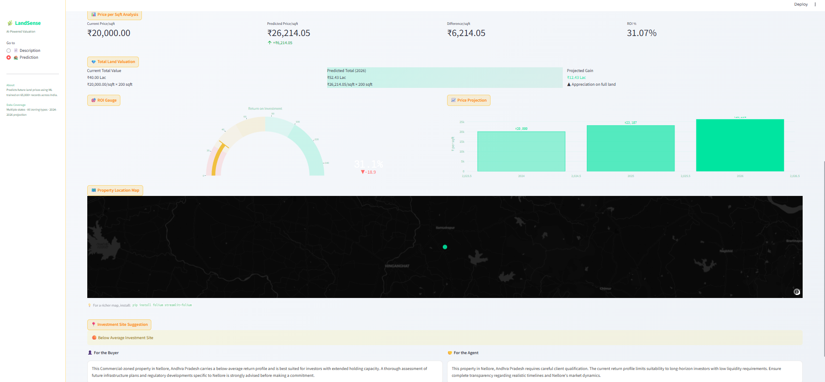
Fig 4: Prediction Results

- CONCLUSION & FUTURE SCOPE
7.1 Conclusion
The proposed Land Price Prediction System successfully automates the process of estimating land price per square foot using machine learning techniques. The system effectively analyses multiple factors such as location, infrastructure, environmental conditions, and growth indicators to generate accurate predictions.
Overall, the system improves prediction accuracy, reduces dependency on manual valuation, and supports data-driven decision-making in real estate investment and planning.
7.2 Future Scope
The system can be further improved by incorporating larger and more diverse real-world datasets to enhance prediction accuracy. Advanced machine learning and deep learning models can be implemented for better performance. Integration with real-time data sources such as government records and market trends can provide more dynamic predictions. Additionally, features like interactive maps, visualization dashboards, and cloud deployment can be added for scalable and user-friendly real estate analytics.

